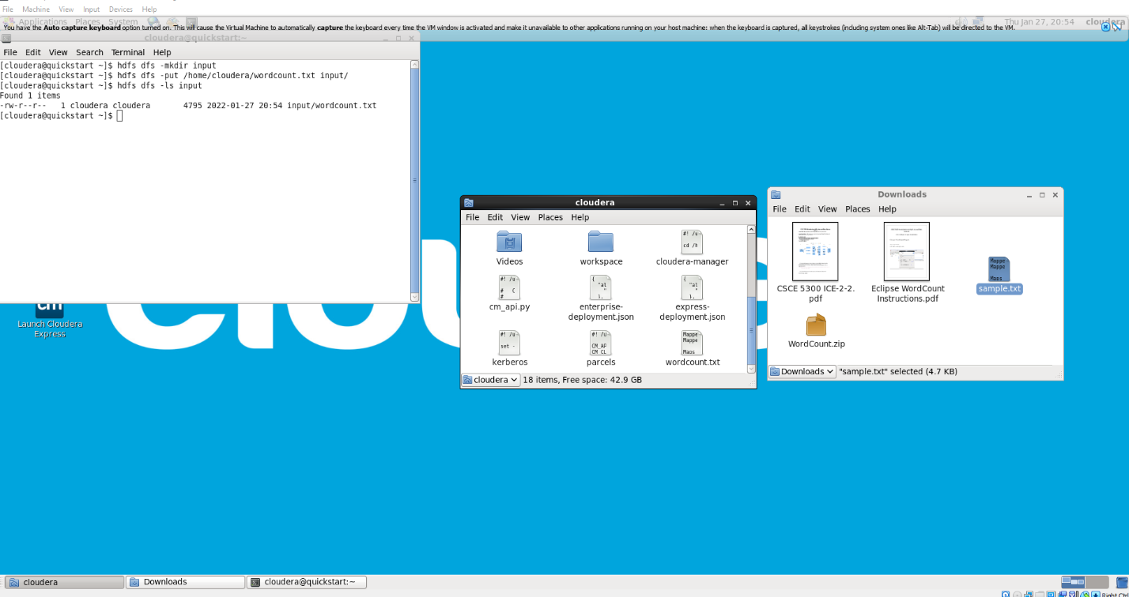

Step 1:

* Create an input folder
* Copy wordcount.txt to input
* List items in input

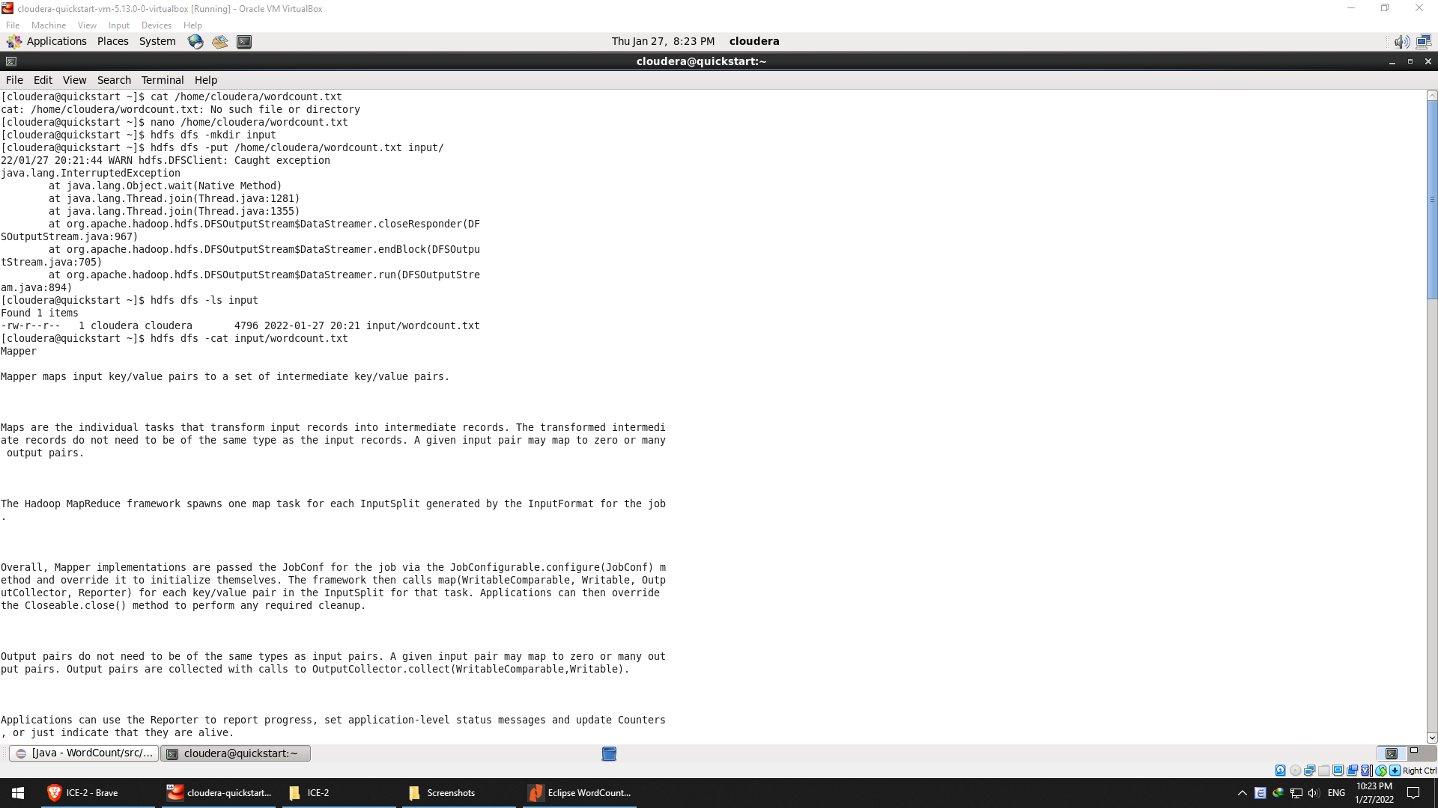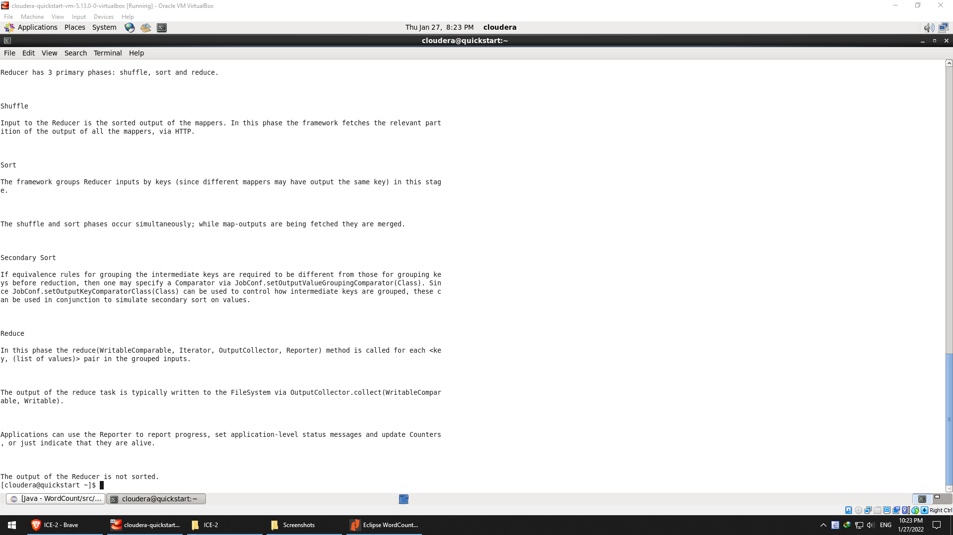

Step 2: Verify the content of wordcount.txt

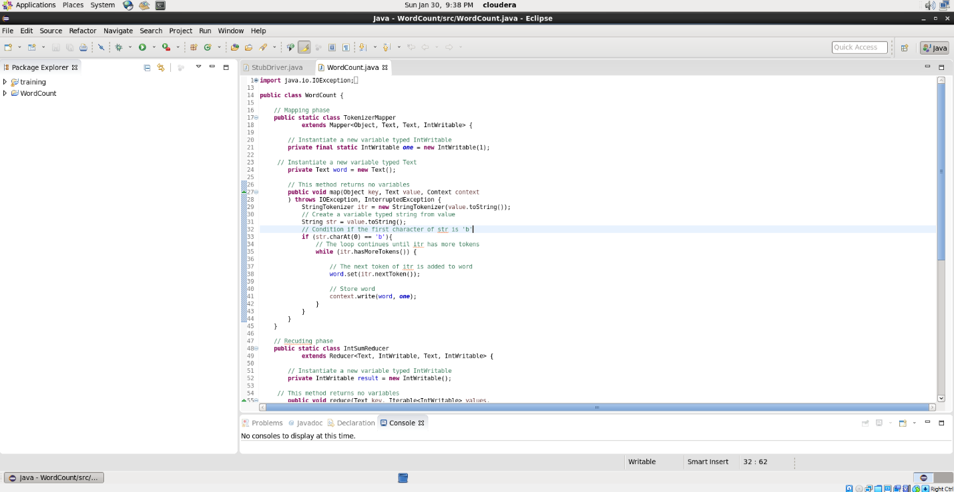

Step 3a: At two lines to the original code to filter words starting with ‘b’ in Map phase.

* Instantiate str typed string originated from value
* If it holds true when the first character of str is ‘b’, the word is processed to the next steps

However, the execution time is over five minutes -> Inconvenient

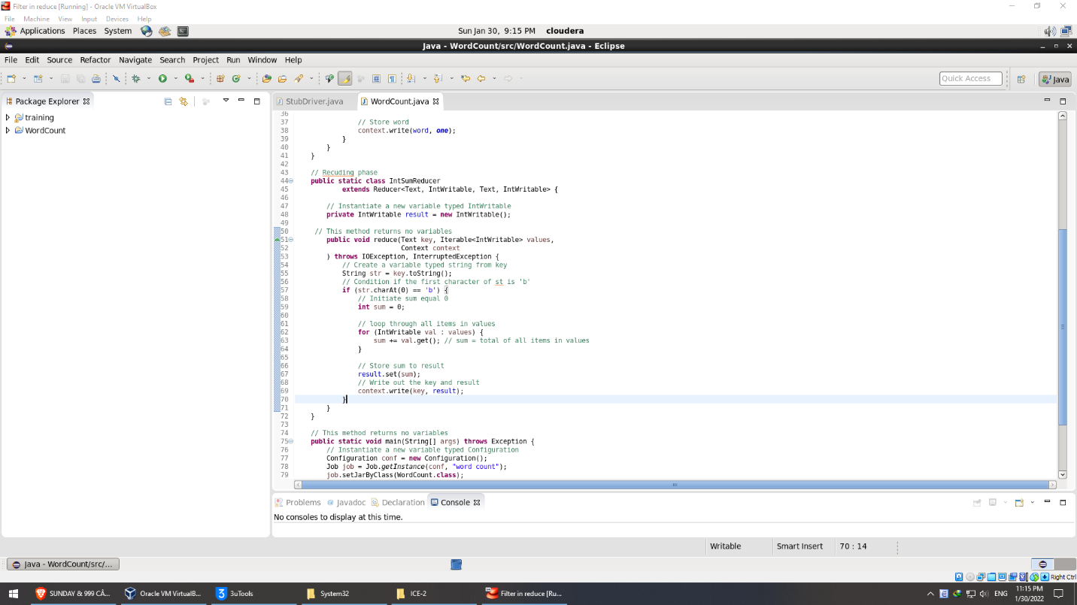

Step 3b: At two lines to the original code to filter words starting with ‘b’ in Reduce phase.

* Instantiate str typed string originated from key
* If it holds true when the first character of str is ‘b’, the word is processed to the next steps

The execution time is around 30s -> Convenient

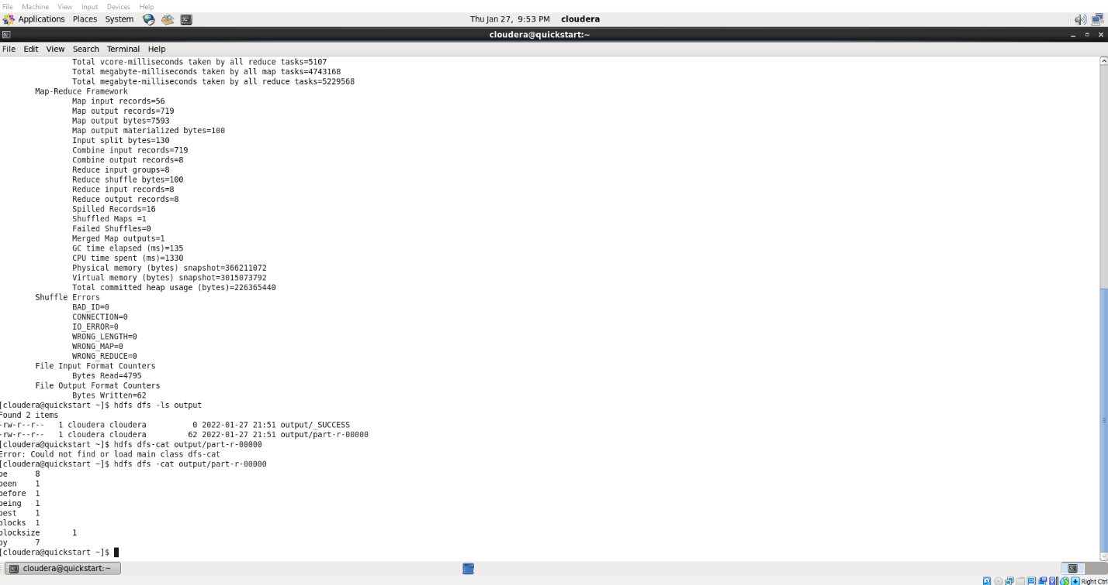

Step 4: Verify the content of the newly written output file